SCC-4179
Restrict CPNI field access to permission set only
Description

Remove FLS access to CPNI fields; delegate via permission set only
Per review with Matt Evrates, the System Administrator, System Administrator - API Only, and Standard User profiles should no longer have Field-Level Security access to CPNI Pin or CPNI Password.
- Remove read and edit FLS for both fields from the three named profiles and from every other profile or permission set that grants access in UAT or Production.
- Access to these fields will be granted exclusively through the permission set "Contact Encrypted CPNI Read/Write Access."
- This permission set allows assigned users to view the fields on the page layout without profile-level FLS.

Attached is an example
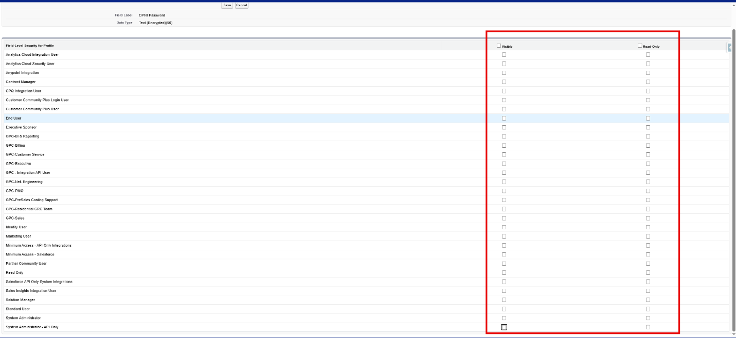

As A
Devops
I Want

Additional CPNI Security

Acceptance Criteria

Pass only when Contact.CPNI_Pin__c and Contact.CPNI_Password__c are unreadable and uneditable through every profile and every non-approved permission set, and read/edit access remains only in "Contact Encrypted CPNI Read/Write Access." Validate both UI and API behavior with named users.

OH Requirement ID Field

None

Architecture
Solution Review

Use declarative FLS only: remove both CPNI field permissions from all profiles and all non-approved permission sets; retain read/edit access only in Contact Encrypted CPNI Read/Write Access. No field schema, Apex, Flow, or page-layout change is required.
Read-only verification on 26 August 2026: changes are still required before promotion. GreatPlainsMerge has CPNI access through the three named profiles plus Account and Contact - Full Access and Heroku and Data Hub Permissions. GreatPlainsUAT also has profile access through Product, GPC-BI & Reporting, and GPC-Residential CRC Team. The intended permission set correctly grants read/edit in both sandboxes.

Solution Type
Declarative Only
Architectural Status
Approved design; implementation changes required before deployment

Deployment
- Disposition: not ready for promotion. No Salesforce changes were made during this review.
- GreatPlainsMerge (00DEa00000GkAsHMAV): the target permission set has 1 assignment; both named fields are still exposed through 3 profiles and 2 additional permission sets.
- GreatPlainsUAT (00DEa00000FZlLBMA1): the target permission set has 2 assignments; both named fields are still exposed through 6 profiles and 2 additional permission-set definitions.
- Production was not inspected or changed. Its complete profile, permission-set, and assignment inventory is a mandatory pre-deployment gate.
Testing Recommendation

Test case 1 - Negative access without the target permission set
- Use an approved UAT user on each affected profile and confirm Contact Encrypted CPNI Read/Write Access is not assigned.
- Open the same synthetic UAT Contact in the record page and Edit action; confirm CPNI Pin and CPNI Password are absent.
- Run an approved API/SOQL check as that user; confirm neither field can be queried or updated.
- Repeat for every profile and non-approved permission set identified by the final FLS inventory.
Test case 2 - Positive access through the target permission set
- Use a named UAT user assigned only Contact Encrypted CPNI Read/Write Access for these fields.
- Open the same synthetic UAT Contact; confirm both fields are visible and editable.
- Enter approved synthetic values, save, reopen the record, and confirm the values persist and render with the expected encrypted-field masking.
- Verify UI and approved API behavior, then remove any temporary test assignment or data according to the UAT cleanup plan.
Test case 3 - Exclusivity and regression
- Query all FieldPermissions rows for both fields and prove the target permission set is the only remaining read/edit grant path.
- Regression-test approved integrations and reporting users that previously depended on profile or broad permission-set access.
- Capture user, profile, permission-set assignments, record ID, timestamps, expected result, actual result, and screenshots in the SCC-4179 evidence.
Runtime status: pending. No user assignment, Contact record, metadata, deployment, or activation was changed during this read-only completion review.

Pre-Deployment

- Retrieve and archive the current Production metadata for both Contact fields, every profile, and every permission set that grants either field.
- Inventory current target-permission-set assignees and obtain Security/Data Owner approval for the final authorized-user list.
- Build a focused package that removes read/edit from every unauthorized access path while preserving read/edit in Contact_CPNI_Read_Write_Access.
- Assess integrations, reports, list views, and automated users that may rely on the two fields; obtain owners and regression tests before removal.
- Run a check-only validation against the target org, record the job ID and exact components, and obtain explicit deployment approval.

Deployment

- Deploy only the approved, focused profile and permission-set FLS changes; do not modify field definitions, layouts, Apex, Flow, or unrelated permissions.
- Retain read=true and edit=true only for Contact.CPNI_Pin__c and Contact.CPNI_Password__c in Contact_CPNI_Read_Write_Access.
- Remove both field-permission entries, or set read/edit false as supported, in every profile and non-approved permission set found by the inventory.
- Deploy to GreatPlainsUAT first. Promote to Production only after named-user UAT, integration regression, Security approval, and an approved change window.
- Record the deployment job ID, final component count, test level/result, start/end time, and any omissions. Do not auto-assign the permission set to new users.

Post-Deployment

- Read back FieldPermissions for both fields and confirm no profile or non-approved permission set grants read or edit.
- Confirm the target permission set still grants read/edit and its assignee list exactly matches the approved list.
- Execute the negative, positive, exclusivity, and integration regression tests above with named users.
- Review Setup Audit Trail and deployment results, attach evidence to SCC-4179, and obtain Business, Security, and QA sign-off.
- If a critical dependency fails, roll back with the approved metadata backup and remove any emergency assignment after the incident is resolved.

DevOps Assignee
Salesforce Release Manager / Salesforce Administrator; record the named owner before the change window.
DevOps Required
Yes
Board
Development
Attachments
1
Technical Documentation
Libraries/Packages Used

None. Standard Salesforce profile, permission-set, and Field-Level Security metadata only.

APIs

No runtime API is introduced. Use Metadata API for the approved deployment and SOQL read-back of FieldPermissions and PermissionSetAssignment for verification.

Triggers or Automations

None. No Apex trigger, Flow, validation rule, or automation change is required.

New or Updated Objects/Fields

No object or field schema change. Existing fields referenced: Contact.CPNI_Pin__c and Contact.CPNI_Password__c.

Components

New: none. Update: Profiles - System Administrator, System Administrator - API Only, Standard User, plus every additional Production/UAT profile found by inventory (UAT currently includes Product, GPC-BI & Reporting, and GPC-Residential CRC Team). Permission Sets - preserve Contact_CPNI_Read_Write_Access; remove both field grants from Account_and_Contact_Full_Access, Heroku_and_Data_Hub_Permissions, and any other non-approved grant path found in Production.

Settings Modifications

Field-Level Security only: remove both field grants from every profile and non-approved permission set; preserve read/edit only in Contact_CPNI_Read_Write_Access.

Error Logging

No application logging change. Release evidence must include validation/deployment results, Setup Audit Trail, FLS read-back, and named-user UAT results.

Temporal Changes

Permanent least-privilege control. Any emergency access must use the approved permission set, be time-bounded by process, and be removed after the approved window.

